Locate new webelement in test project

Press double shift to identify elements

Open in element locator

Add element

Save the elements

Create new job

Drop the test inside job

Open Jenkins

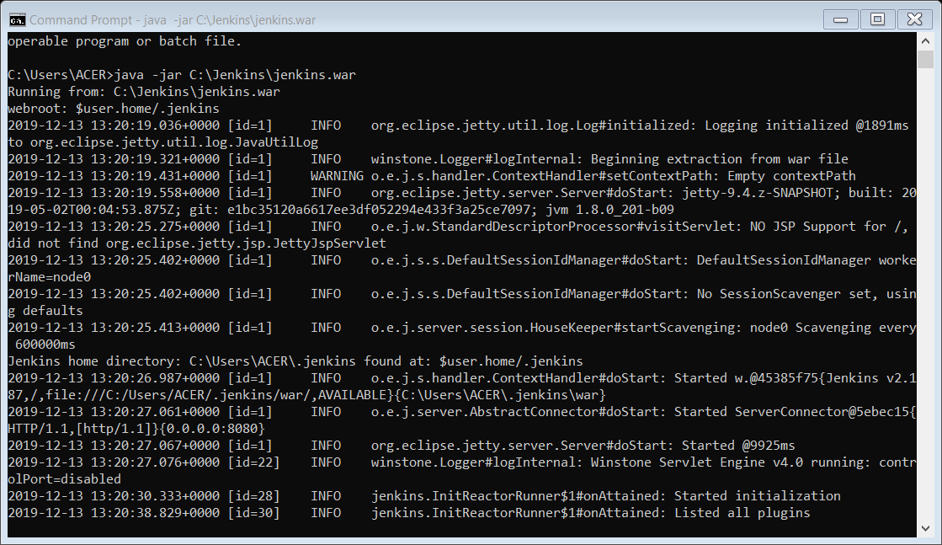

Click on check now option

It will download all the updares for all the plugins

Install test project plugins

Create api key for connecting with Jenkins

Key got created

Key – generated – copy the key

Go to manage Jenkins > configure

Copy paste the api key

gIQzvHpZaNf4b-GbomrJAqF-bCs8Vlv7_ZBgWuCo-7E1

Go to test project and copy the project id

Open the project and copy the job id

Give job id and project id

Job run successfully

Configure new job

Change job id

Executed by Jenkins build